**Selenium IDE**

Selenium IDE (Integrated Development Environment) **is the simplest tool** in the Selenium suite

**Selenium IDE:**

PROS:

1. FireFox plugin with Record/Playback, Edit and Debug test in Browser.
2. Script gets recorded in **Selenese** language
3. It helps in exporting test that can be executed in Selenium RC & webDriver.
4. It allows the user to add Assertions and Verifications.

CONS:

1. Available only in Firfox Browser
2. No support for iteration and conditional operator
3. Test execution is slow compare to RC & Webdriver

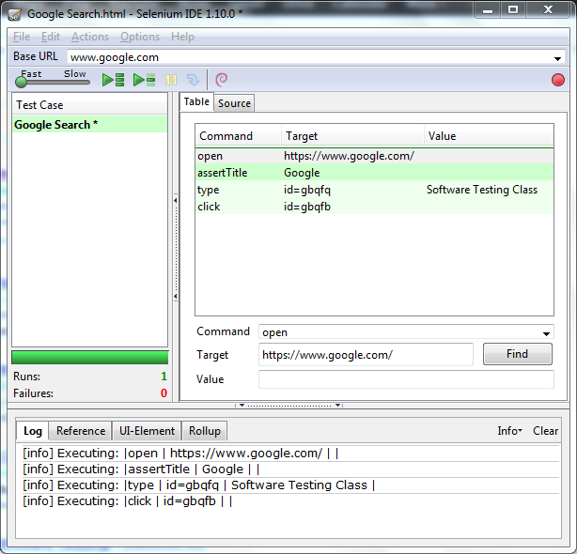

**Locators in Selenium IDE:**

1. Id
2. Name
3. Classname
4. cssSelector

Tag and ID

Tag and class

Tag and attribute

Tag, class, and attribute

Inner text

1. xpath
2. link
3. DOM

getElementById

getElementsByName

dom:name

dom: index

**Selenese combination of 3A’s:**

1. **Action:** To perform action on element or used to change the state of AUT (Click, Close, doubleclick)

2. **Accessor:** To check the state of the application and save the application state in some variable

E.g.: storeTitle , storeElementPresent

3. **Assertions:** Verifies the state of the application matches it with the expected state and generates the

True/False result.

E.g. : verifyText, assertText

**Selenese Commands:**

|  |  |
| --- | --- |
| Open | Opens a page using URL |
| Click/ClickAndWait | Performs a click operation, and optionally waits for a new page to load. |
| VerifyTitle/assetTitle | Verifies an expected page title |
| VerifyTextPresent | Verifies expected text is somewhere on the page. |
| VerifyElementPresent | Verifies that an expected UI element, as defined by its HTML tag, is present on the page. |
| VerifyText | Verifies that expected text and its corresponding HTML tag are present on the page. |
| VerifyTable | Verifies a table's expected contents. |
| waitForPageToLoad | pause execution until an expected new page loads. Called automatically when clickAndWait is used. |
| waitForElementPresent | Pauses execution until an expected UI element, as defined by its HTML tag, is present on the page |

**Selenese commands for Alert:**

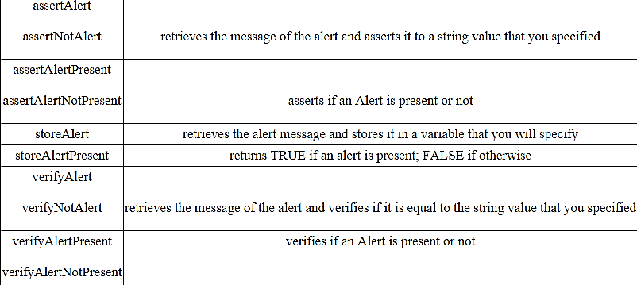

**Exporting Script to multiple language:**

We can export Selenium IDE script into Selenium webDriver and RC in required language.

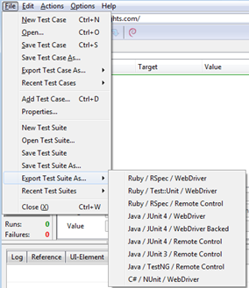

**Note:** The default format for Selenese commands is HTML.